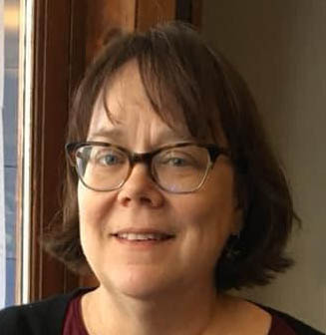 Lesley Carey Bio:

Lesley Carey is the College Archivist at Williamson College of the Trades and works in Archives and Special Collections at Saint Joseph’s University. She is a graduate of Clarion University’s Library Science program and has done two sessions of Rare Book School. She won a William T. Buice III Scholarship for another session in 2022.

In the archives, Lesley focuses on creating access to collections by writing and publishing clear finding aids and on organizing physical materials to be easily accessible to researchers. She collects books, especially pop-up books and poetry and is currently working on a book annotation project.

Being an archivist is her third career and she is always happy to be touching and processing archival materials.